**CSS Basics**

**DEADLINE:** 16/04/2022

## **FOLDER STRUCTURE** * ­­­- required

FL-19_HW2/*

├─ task/

     └─ FL-19_HW2.docx

   └─ homework/*

        └─ css/*

            └─ bootstrap.min.css*

└─ general.css*

└─ style.css*

        └─ img/*

     └─ index.html*

## **TASK**

1) Add box shadow to navigation and each content block. Add grey border to the banner.

You can use this style “box-shadow: 0px 0px 12px 0px rgba(61, 55, 61, 0.7);

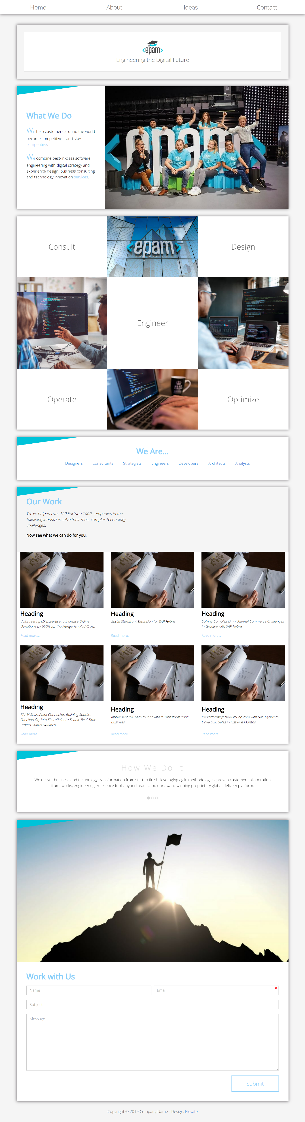

**Figure 1 — Blocks shadow and banner’s border(mockup)**

2) Add hover effect for navigation items (background lightskyblue (#87CEFA) color) (Figure 2).

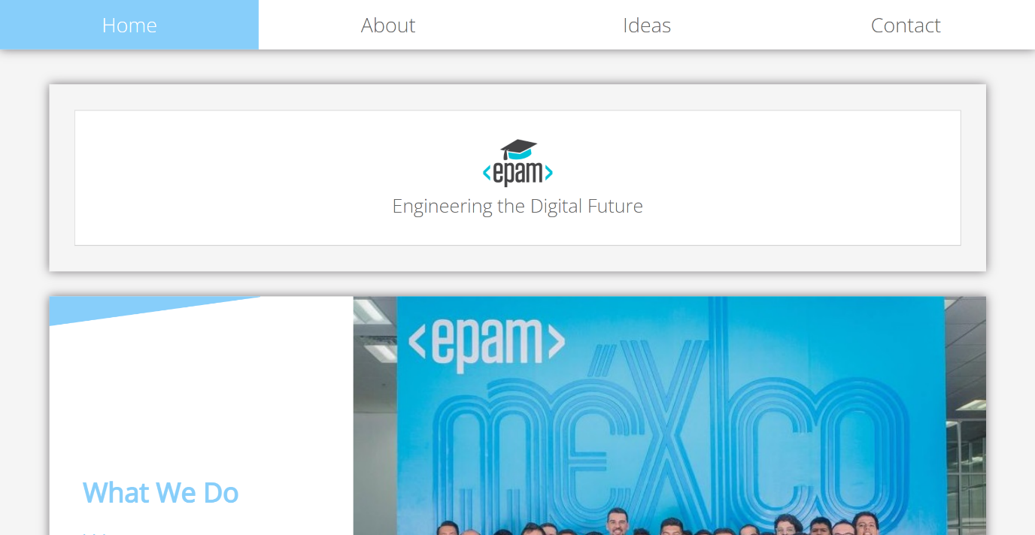

**Figure 2 —** **Hover effect for navigation items (mockup)**

3) In each section change color text to lightskyblue (#87CEFA) and font weight to bold for title.

- In section with “main” id change color of first and last word in each paragraphs to

lightskyblue (#87CEFA).

- Text block should be on the left side and image block should be on the right side.

(see Figure 3).

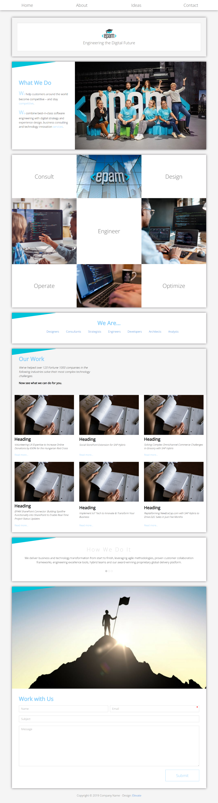

**Figure 3 (mockup)**

4) Lets look closer at this part of site. Tiles with text should have change background color to

lightskyblue (#87CEFA) on hover effect with transition (.5s) and change text weight bold on hover. Replace each image as shown at the figure 4. You can find the image files in the project folder: homework/img/

(see Figure 4).

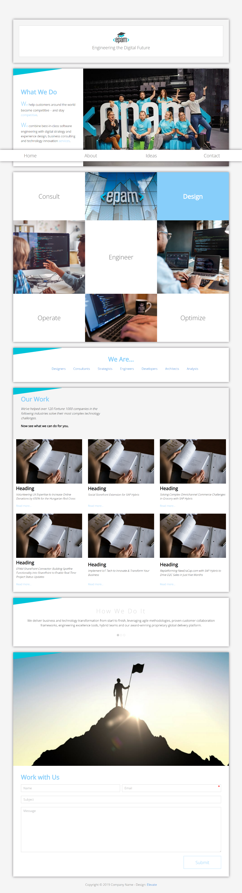

**Figure 4 — Gallery block (mockup)**

5) Add triangle to each section on the page using pseudo elements. (see left top corner in Figure 5)

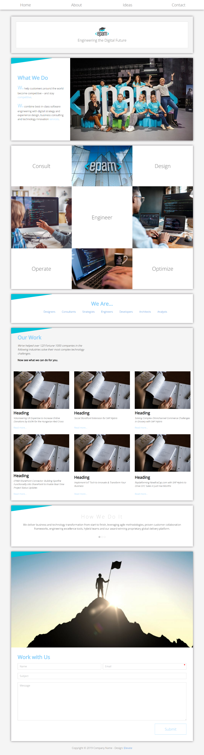

**Figure 5 – Triangle (mockup)**

6) In section with “we-are” id **(Figure 6)**:

Change each letter of the title with a capital letter and align the text the center.

Change list items horizontally instead of vertically and indent between each item 20px.

Remove marker for items of list.

Already visited links should become underlined.

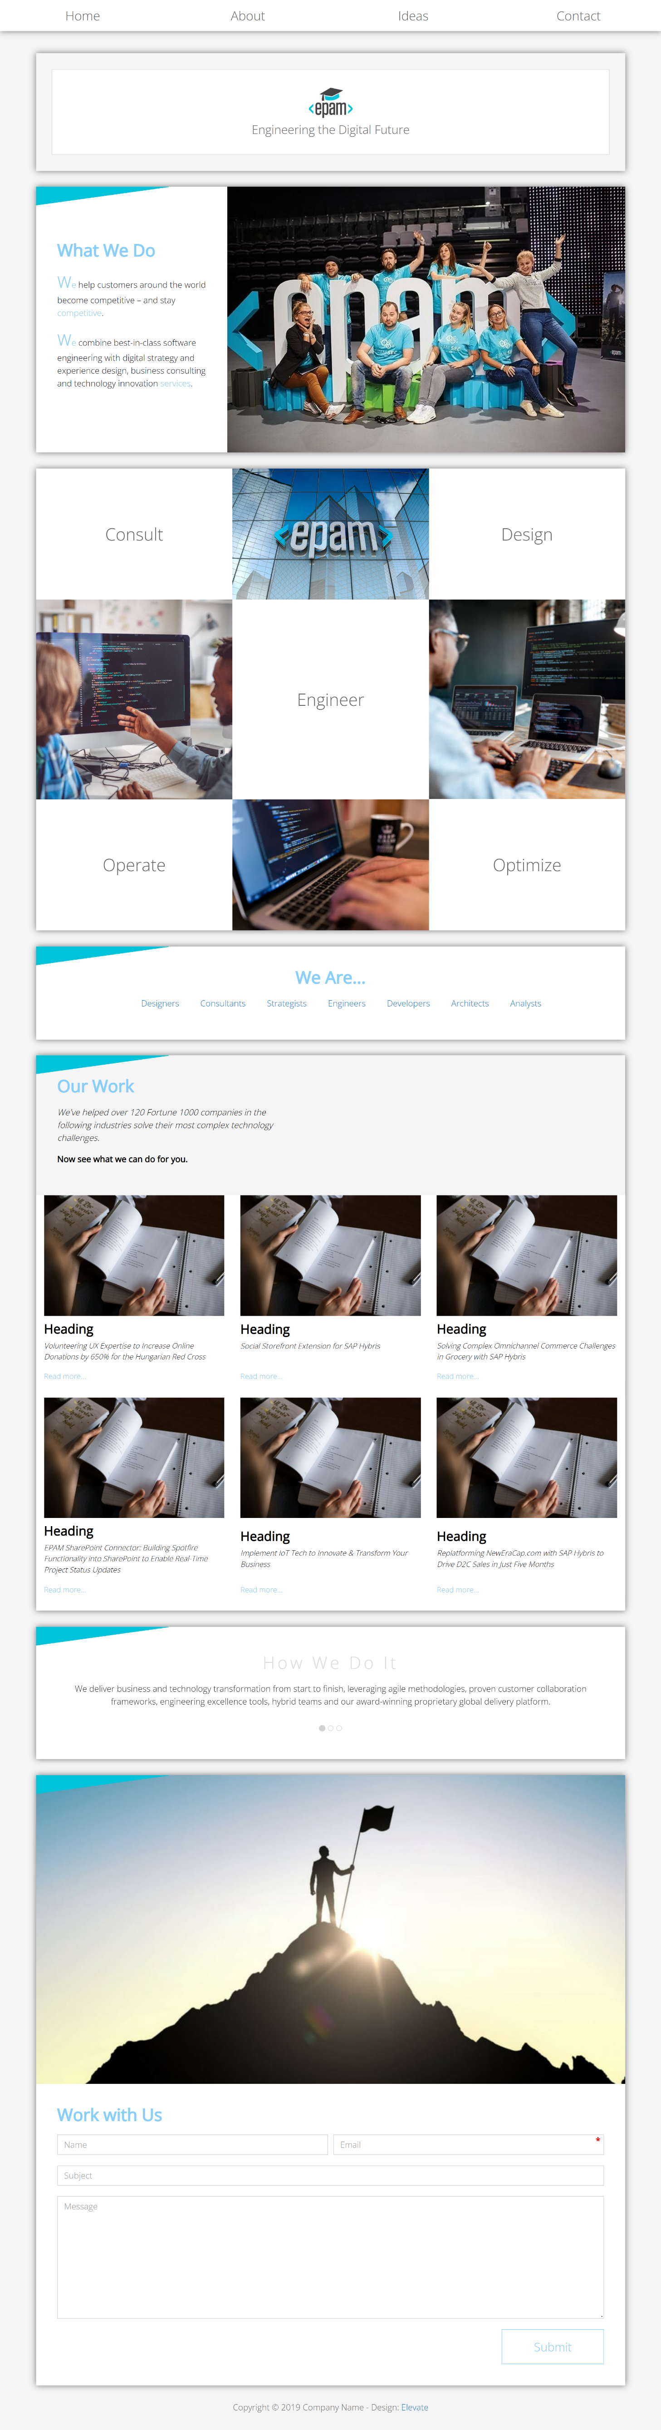

**(Figure 6)(mockup)**

7) In section “our-work” id :

- First paragraph should have italic style.

- Second paragraph should have font bold.

8) Add layout and styles for following block. **(Figure 7)**

Lets look closer at this part of page:

-The tile should have the same styles as in the example.

- Add “Read mode”, it should be <a> tag.

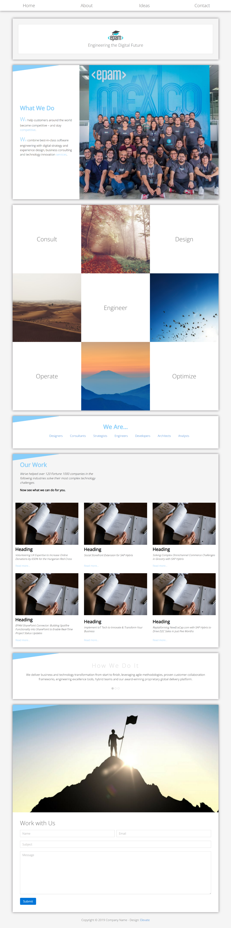

**Figure 7 —Block styling (mockup)**

9) Change color of ‘How We Do It’ to gainsboro and add letter spacing 5px.

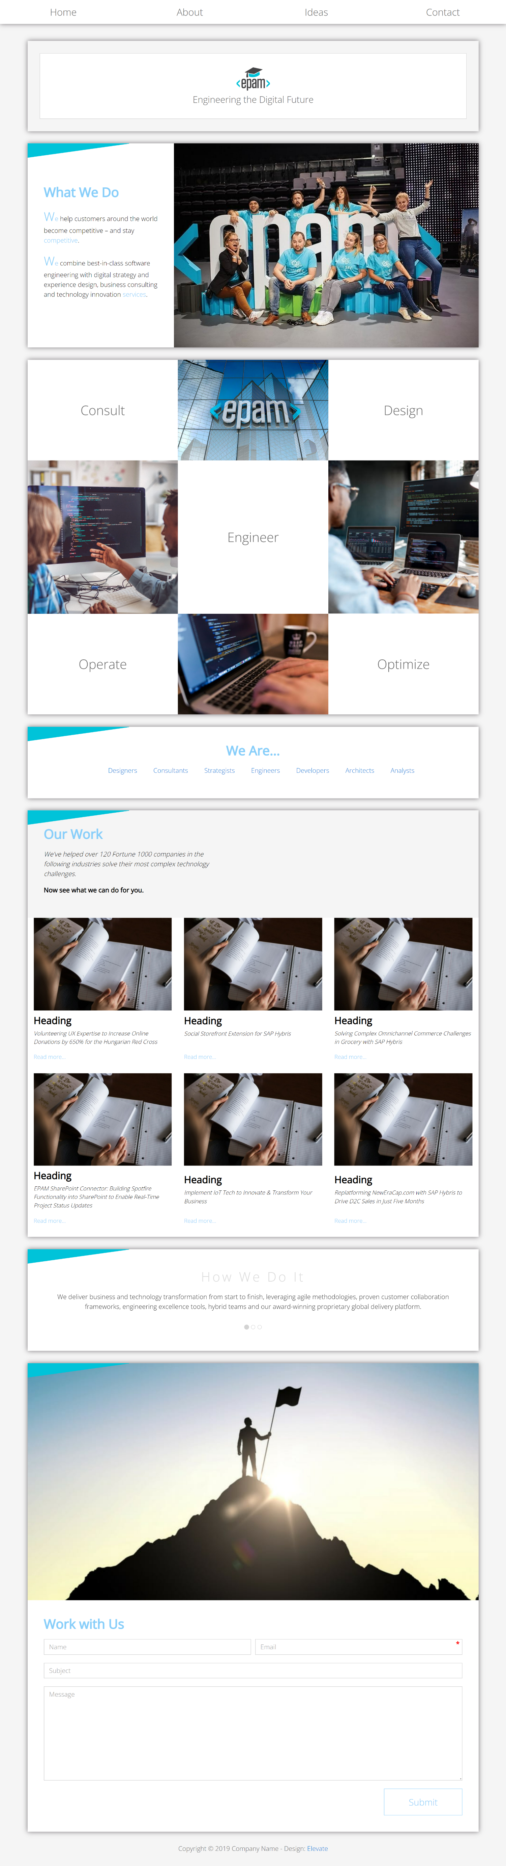

**(Figure 8)(mockup)**

10) Change submit button styles. Add asterisk to email field (Figure 9 and Figure 10).

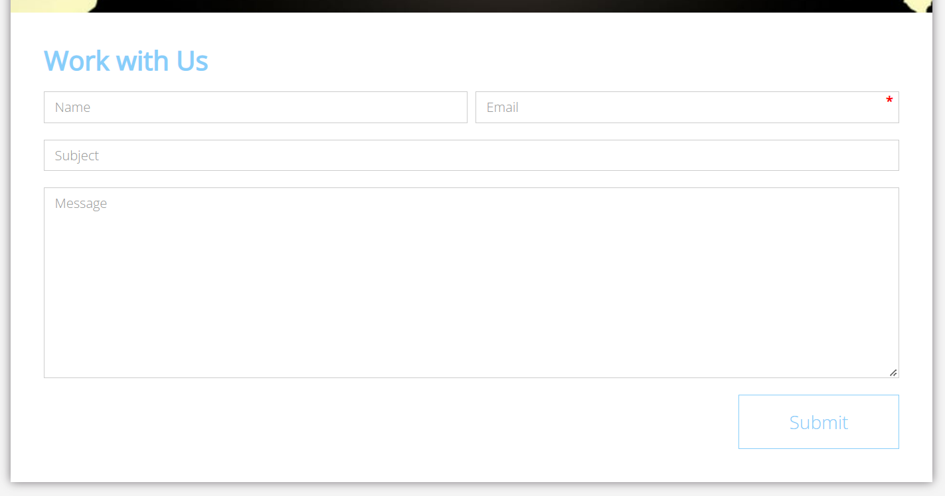

**Figure 9 —Work with Us form (mockup)**

The submit button should have a hover effect:

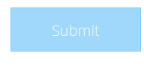

**Figure 10 —Submit button in hover state (mockup)**

11) You need to create a print version of the web-page. In the following pictures, you will see mock-ups which represent almost finished site (this is what you need to achieve). In case, you don’t know how to open print version of the page, you should follow the next steps:

* Open index.html file in a browser
* press ctrl+p (or cmd+p for Mac)

Now you can see the first printed page looking like this (see Figure 11):

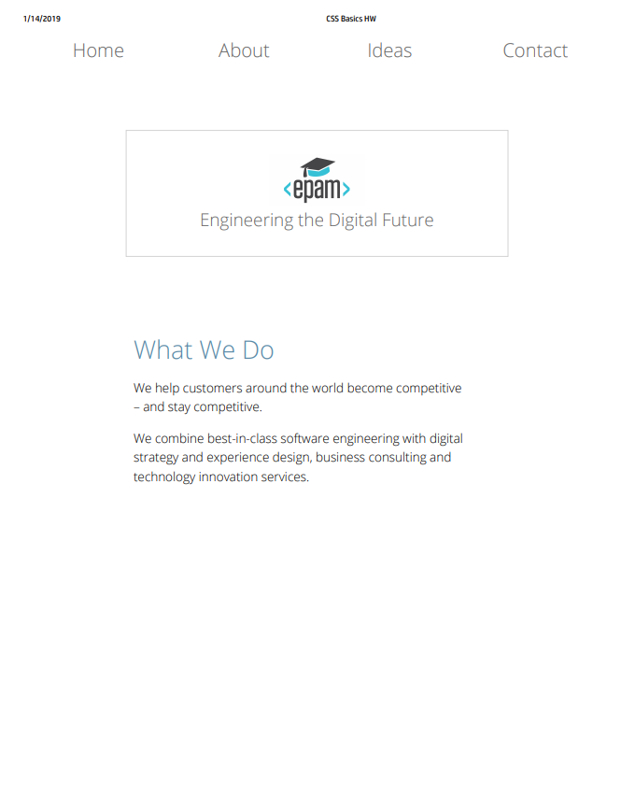

**Figure 11 — Print version**

As you can see, the preview looks not so good and we should improve it. The result should look close (not pixel perfect) to the provided example in Figure 12. Pay attention, only the first section should be available for print (“What we do”)

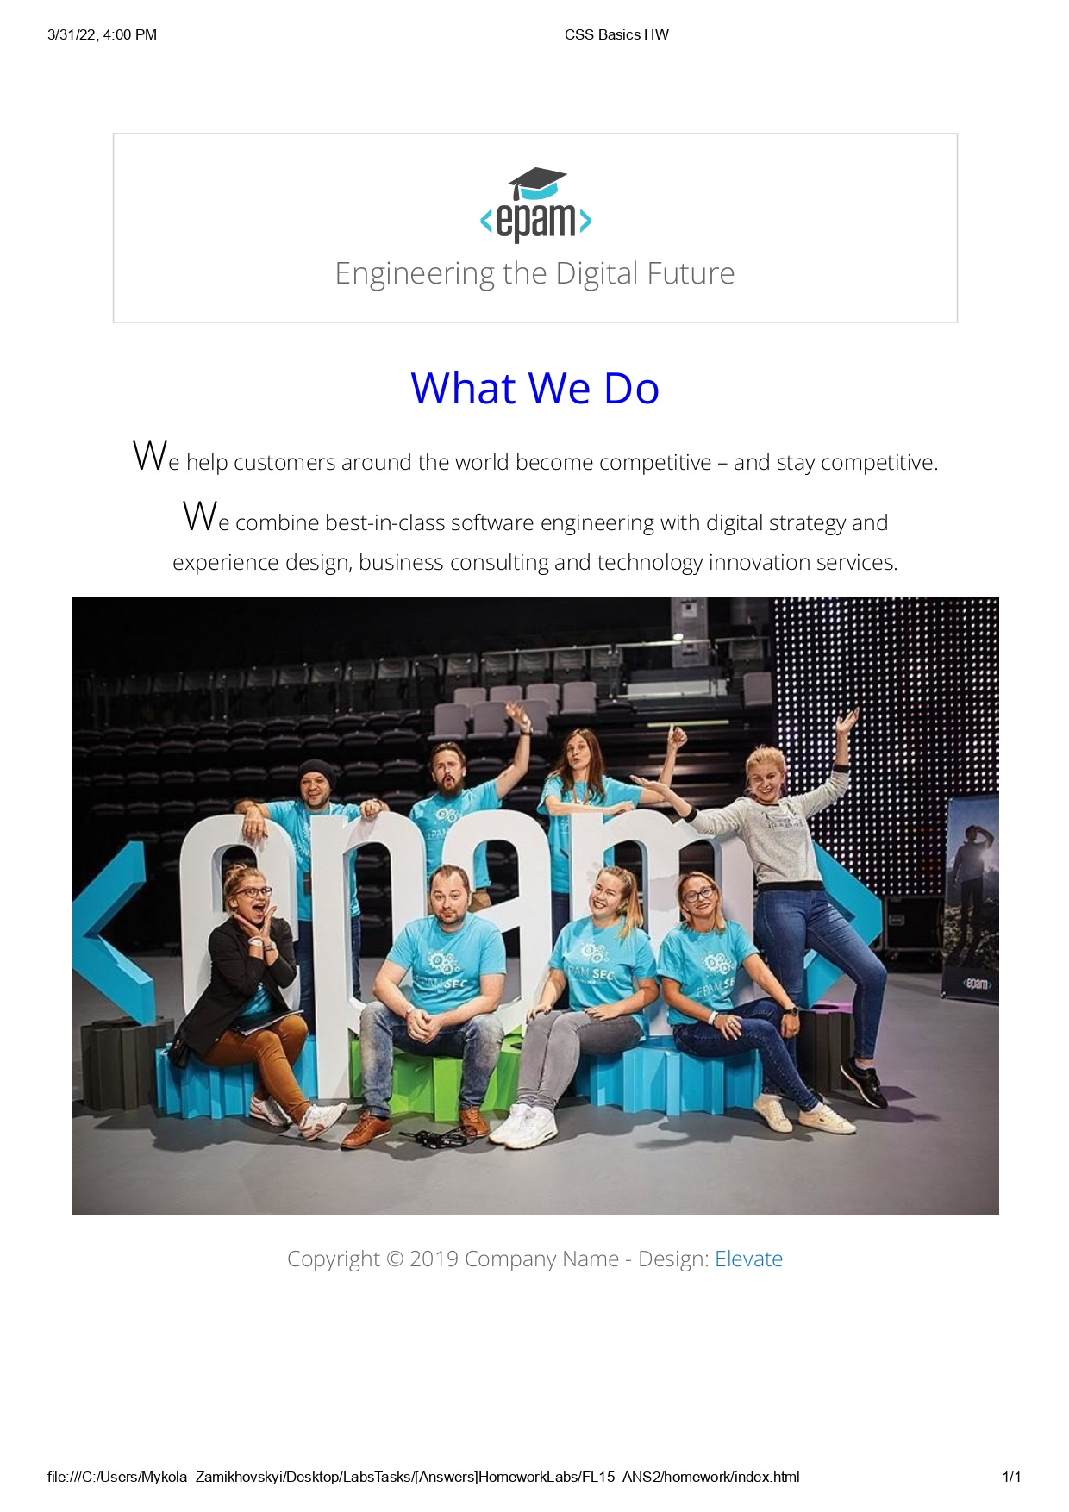**Figure 12 — Print version (mockup)**

## **RESTRICTIONS**

* Adding/editing styles in the **general.css** file is forbidden

## **BEFORE SUBMIT**

* Read requirements and compare to your homework result
* Format the code (remove unnecessary lines of code)
* Remove all unnecessary files that you might have included by mistake

## **SUBMIT**

* The folder should be uploaded to github repository **“FL-19**” into **main** branch